**Database Technologies**

**UE19CS344**

**6th Semester, Academic Year 2021-22**

Week #: 2 - DBMS Concept Recaps (SQL CRUD)

(Lab 2)

Date: 25/1/2022

|  |  |  |
| --- | --- | --- |
| Name :  SUMUKH RAJU BHAT | SRN :  PES1UG19CS519 | Section :  H |

(Starts from next page)

Please note: It was told to write the queries on paper. Since, there were no proper data to be inserted into the tables of the miniworld, random data was generated for further assignments and this meant more often than not, the queries resulted in empty results(especially for complex queries) as the data is not well-formulated.

1. **DDL Command on one of the tables:**

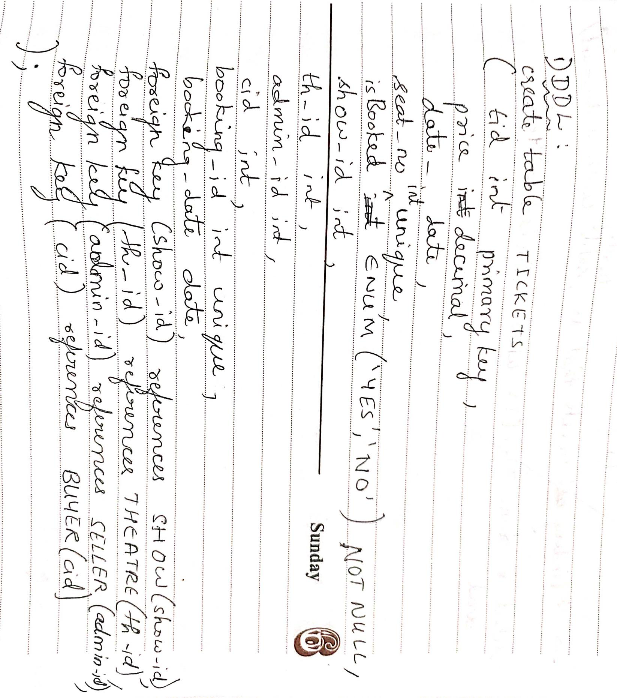

1. **DML Commands:**

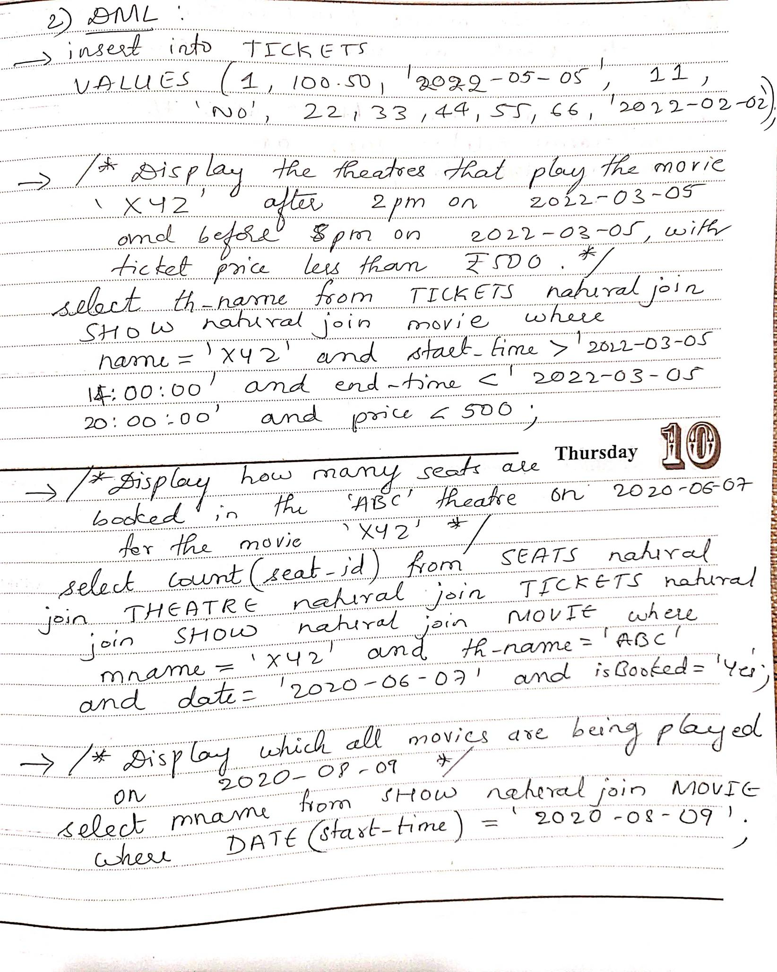

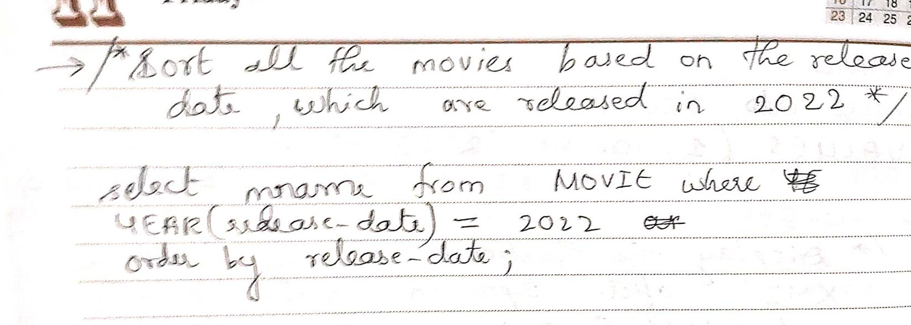

**Update and delete:**

update tickets

set price = 2*price

where isbooked = 0;

delete

from tickets

where isbooked = 1;